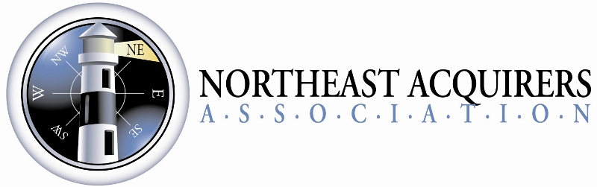

Catapult 2018 Innovation Program Rules and Submission Instructions
- By submitting this entry the entrant is agreeing to each of the rules as published in this document.
- Each entrant must submit their entry of the approved Catapult 2018 Innovation Program entry form no later than 5pm Pacific time on Friday, December 15, 2017. Entries received after that time will not be accepted.
- Each entry will be evaluated by the Catapult 2018 judges. Four entries will be chosen as finalists. All finalists will be notified by email end of day Monday, January 8th, 2018.
- Each finalist will appear before the Catapult 2018 panel of judges and the NEAA attendees at the NEAA opening General Session on Tuesday, January 30th, 2018 (Catapult 2018 Program will be from 3:00pm to 5:00pm prior to the Opening reception). The order of the finalists’ appearance will be determined by an on-stage drawing of the numbers (1-2-3-4) by the finalists. Each finalist will have 10 minutes to present his/her product/innovation.
- Finalists have until Friday, January 19th, 2018 to submit their PowerPoint presentation to the NEAA.
- Judges will rate the finalists on the following criteria:
  - Originality
  - Revenue opportunity
  - Presentation quality
  - Impact to the market
- Prizes will be awarded as such:
First Place: Catapult 2018 Innovation Award Winner:
- $1,000
- Complementary Exhibit space in the ETA’s Transact18 Payments Next Zone (April 17-19, 2018 at Mandalay Bay, Las Vegas)
Second Place: Catapult 2018 Runner-up: $500
Third Place: Catapult 2018 third place: $300
Fourth Place: Catapult 2018 fourth place: $200
- All innovation entries must be in production and not in development at the time of competition.
- Companies can submit up to two different products/innovations on separate forms.
- The decision of the judges is final.
Submission Instructions:
- Please fill out and save the form with your company name in the file name (by using SAVE AS, then adding your company name to the name of the file).
- Email your form to donna@northeastacquirers.com no later than 5pm Pacific time, Friday, December 15, 2017.
- By submitting the form, you are indicating your acceptance of the rules of the Catapult 18 innovation event.
- For more information or a copy of the rules, see http://www.northeastacquirers.com/Catalpult18-innovation.php

